filename : svm.ipynb

1)No, linear classifier cannot segregate this set of data completely accurately.
SVM classifier classifies data set with more accuracy than a linear classifier.
From confusion matrix we can see that our SVM model is 90% accurate, hence we can rate it as 9 out of 10.

Filename - SVM Classification.ipynb

1) Maximal margin hyperplane is the hyperplane that has the largest margin, meaning, which has the largest distance between the hyperplane and the training observations.
It can be found by calculating and maximizing the perpendicular distance between the plane and points of the dataset.

2) SVM with RBF kernel trick is used find higher level hyperplane on non-linear data.
When the data set is linearly inseparable or in other words, the data set is non-linear we can use RBF. RBF Kernel function will allow us to introduce a hyperplane which will help us distinguish the given data set by uplifting one of the data set.

3) Gamma is an hyper parameter that is responsible for over-fitting of the curve.
Gamma is directly proportional to curve over-fitting, therefore more the value of gamma more will be over-fitting and lesser the gamma lesser will be the over-fitting.

4) svm = SVC(kernel='linear', random_state=1, gamma=0.10, C=10.0)
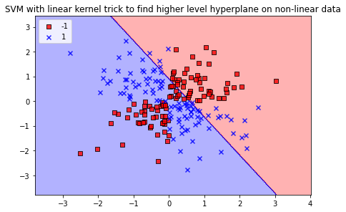

If we change the kernel trick from RBF to linear we’ll get a linear classifier which cannot classify the given the data set properly.

5)svm = SVC(kernel='rbf', random_state=1, gamma=1.0, C=1.0)
If we change the gamma from 0.2 to 1.0 the classifier starts to over-fit.
